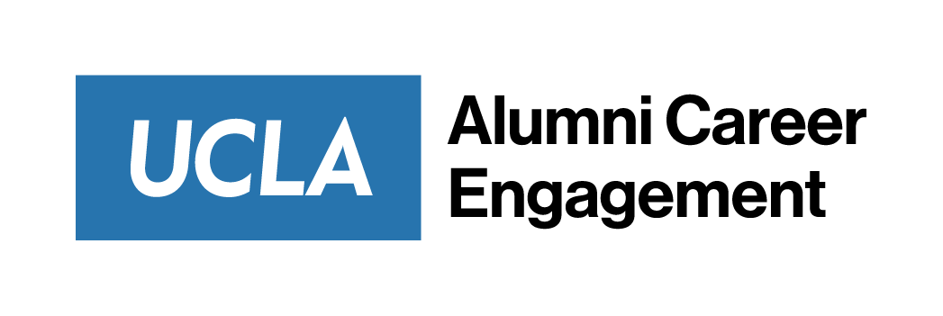

Email Templates
Informational Interviews:
SUBJECT LINE: Request for Informational Interview
Dear Mr/Ms. [Last Name],
My name is [Name] and I am a new graduate of UCLA. I am currently exploring opportunities in [industry] in [location]. In your [online platform] profile, you shared your experience at [company] and I would love to learn how you achieved [the success or position]. It is alumni like you that fuels my interest in this field, and I would be honored if I could learn more from your experiences.
I’m hoping you might have 15 to 30 minutes to meet with me in the next few weeks over video chat or phone. I also recognize that you might have a tight schedule, and am also happy to do this over email if you prefer. Please let me know if this might be possible and what dates and times are most convenient for you. I look forward to hearing from you.
Thanks,
[Name]
Interview Email Follow-up:
Dear [Interviewer],
Thank you for the opportunity to interview for [Company]. It was a pleasure learning about the role, its responsibilities, and how I could be of service to your team.
[Share one new piece of information you learned]
[What about this piece of information kept you interested in the job?]
I hope that my passion for this role was evident and that you would consider me in your hiring process. If you should need any more information or clarification of my interview, I am available as you need. Thank you again for this opportunity.
Best regards,
[Name]

